

**Faculty of Engineering and Information Technology**

**Computer Science Department**

**Comp 2310 Assignment #2**

|  |  |
| --- | --- |
| **Individual work assignment.** | **Due Date: Wed. 20/12/2023 by 10:00 pm on *ITC*** |

Given the following UML diagram for class Chair:

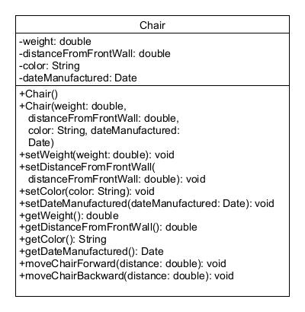

Please do the following:

1. Create a class file called Chair.java that implements the UML displayed above ***exactly as specified*** (same variable names, types, …). Also, make sure that the no-arg constructor calls the all-argument constructor and provides default values for the properties.
2. Create a class file called Room.java that implements a class called Room that has the following properties and constructors/methods:

Properties (All Private): number (int), length (double), width (double), array of type Chair called chairs.

all-argument constructor that initializes all Room properties

setter/getter methods for each of the properties above

method displayRoomInfo() which prints a room’s number, length, width, and total number of chairs in a room, as well as the number of chairs of each color (red, yellow, or white).

***You should also create a UML diagram for this class as described below***.

1. Create a class file called Driver.java that implements the Driver class which should implement the following two methods:

***main*** method which should create an array of room objects called rooms (For this program, set the size of the array to exactly 3). To initialize the property values for each room in array rooms, you should do the following:

1. Create an array of chairs with a random number of chairs between 20 and 50 (inclusive) and add that number of Chair objects to the array. Each Chair object added to the array should be given the same default value for properties weight and dateManufactured. As for property distanceFromFrontWall, each chair should be given a random value that does not exceed the length of the room. For the property color, you should assign a random color out of the following three colors only ( red, yellow, or white). Use the Random class to do those.
2. Use the all-argument Room constructor to set a number for each room ( Use 201,202,203 sequentially in this case), a random number from 30.0 to 50.0 for room length, and a random number from 20.0 to 30.0 for room width. Use the Random class. Also set the room chairs using the array created in point a- above.

***displayRooms*** method which takes an array of type Room as an argument and loops through it displaying the property values for each room in the array (you should call the method displayRoomInfo() to do that). The table should be organized as follows:

***number length width total chairs red yellow white***

***e.g.:***

***201 45.34 25.20 42 12 19 11***

***Your Driver class should define a constant called SEEDVALUE which is the value of the seed to be used when you create your object of Random Type to be used in all your program. You should use the same created Random object (ONE OBJECT ONLY) with the same seed (SEEDVALE) to generate all the random values described above (using the suitable methods in the Random class). NOT doing this step correctly will cause you to lose many points.***

IMPORTANT: What you need to turn in:

1. Using one of the free UML drawing tools ( e.g. UMLet ), draw a complete UML diagram for the Room class and insert an image of it in a Word file called ***room_uml.docx*** then put that file inside your project folder*. In the UML, each student should replace the name of the properties length and width to length#### and width#### where #### is the last four digits of his/her university id number (this is only done in the UML and not in the implementation above).*
2. Your project folder ( containing all your project files ( *.java files and file *room_uml.doc* ) should be compressed (.rar) and saved as ***ass2_youridnumber_yourLabsectionnumber.rar***  ( for example if your student id number is 1221234 and your lab **section** is section 9 then the assignment project folder should be called ***ass2_1221234_s9.rar*** ). Turn in your assignment by ***replying to the course coordinator’s message*** on itc under the lab meta section and attaching your project .rar file (***ass2_youridnumber_yourLabsection.rar***).
3. You must include your full name, student id number, and lab section number in a comment at the beginning of each of your .java code files.

Late Assignments (even one minute late) will NOT be accepted for any reason.